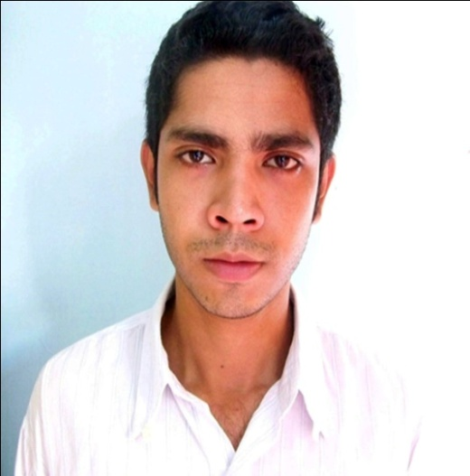Curriculum Vitae OF

**Mahmudul Hassan**

Shuvo0201@gmail.com

88-01685-462905

I can take responsibility to finish a job. I enjoy programming and team work. I want to join in such an interactive environment which would offer me a constructive workplace and a stable introduction to the IT world.

**My Works**

**Mobile to PC control via Bluetooth :**  An automated system that receives instruction from mobile and perform as it says. Like a file explorer you can brows whole PC like as windows explorer. I developed a server for pc in java and a J2ME program for java supported mobile which connects through Bluetooth to exchange data and PC execute those programs using run.

**Bangladesh Railway Website :** We build a prototype of Bangladesh railway website and some improvements on the site. Later on they add the improvements on the site. The total site is built on ASP.net and I built some pages like as home, schedules etc.

**ACME Database Management software :**  It is a desktop application which can keep record of whole database of drugs and including clients payment. This application can provide the complete management service to ACME. For this software I use visual studio and SQL server.

**File Compressor :** Implemented with NetBeans IDE(java) and it can compress any text files. Little improvement it can work on any file. Using Huffman algorithm it can compress any file with facility of adding icon to the folder and can set your own extension.

**Simple Data Encryption and Decryption :** Encrypts as well as decrypts data using RSA algorithm.

**Internet Download Manager :** Implemented with NetBeans IDE(j2me) can use the highest bandwidth of the internet connection and also can limit the download speed for safe browsing. This software connects pc via com port and downloads. I made this whole system.

Moreover, I have also developed **LED counter**(electronically), **1 bit ROM**(electronically), **t-Shirt purchasing site**(html,css), **Puzzle Game**(java).

**Technical Skills**

Proficient in : C, Java(J2SE,J2ME), C#.net

Familiar with : ASP.net, PHP, Wordpress

Database : MySQL, SQL server

IDES : Net Beans, Visual Studio and Dreamweaver.

Networking : DNS, Web and Mail server configuration in ubuntu.

Other : Adobe Photoshop, Microsoft Office and power point.

**Academic Achievements**

|  |  |  |  |  |
| --- | --- | --- | --- | --- |
| **Level** | **Institute** | **Passing**  **Year** | **Board** | **CGPA/GPA** |
| B.SC in CSE | Khulna University | 2012 | ----------- | 3.10 |
| H.S.C | Notre Dame College | 2007 | Dhaka | 4.60 |
| S.S.C | St. Joseph’s School | 2005 | Jessore | 5.00 |

**Language Skill**

I am efficient in reading, writing, listening and speaking English and Bengali also can speak in little bit Hindi.

**Last but not the least**

I enjoy programming and participated two times in **ICPC programming** **contest** on behalf of my university. With my university friends each year I collect clothes, money and other necessary things to help the poor people of our southern coast during winter.

|  |  |
| --- | --- |
|  |  |

**Personal Details**

Full Name : Mahmudul Hassan Shuvo

Father’s Name : M.A.Matin

Mother’s Name : Mazeda Begum

Date of Birth : December 6, 1989

Religious View : Muslim

Nationality : Bangladeshi

Marital Status : Unmarried

Present Address : 33,A,N,Das Lane Tutpara, Khulna – 9100, Bangladesh

Permanent Address : 33, A,N, Das Lane Tutpara, Khulna – 9100, Bangladesh

Phone Number : +88-01685-462905

E-mail : [shuvo0201@gmail.com](mailto:shuvo0201@gmail.com)

**References**

**SK Alamgir Hossain**

Assistant Professor

Computer Science and Engineering Discipline,

Khulna University,

Cell: +880711144146

Email: hira_ku2003@yahoo.com

**S.M. Mohidul Islam**

Lecturer,

Computer Science and Engineering Discipline,

Khulna University,

Cell: +8801727043774

Email: mohid_ku@yahoo.com

|  |
| --- |
|  |